APPLICATION OF DECIMAL TO BINARY CONVERSION:

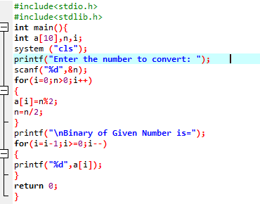

OUTPUT

